**Continuous no-lag Countdown Timer**  
  
This indicator counts down continuously. The indicator published by William Kreider can be found as per above link #Post 9. Thanks to William Kreider for posting.  
Many will prefer this indicator to the start-stop tick dependent variety. However, the original published code has a noticeable flaw. See below image.

*Attached Image*

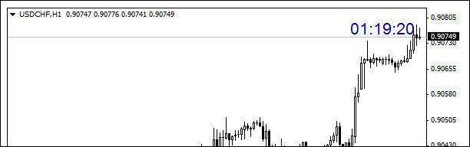

A H1 chart cannot have a remaining time of 01:19:20. This should be 00:19:20.  
  
I have attempted correction of above flaw but cannot anticipate every scenario.

* I have tested correction on 3 different MT4 Terminals with Broker Times at GMT, GMT+1 and GMT+3
* I have added some enhancements and new bar/candle alert. A version without alerts is also available.

**Note 1:**The above two indicators will not work if any other version of Countdown Timer is still on the chart. There will be a conflict of code. Before attaching one of the below indicators to a chart ensure that *all*other versions have been removed.  
  
**Note 2:**If the indicator is placed on a market that is closed it will not be visible on the chart. When the market opens the indicator will become visible and start counting down.  
  
**Note: 3:**If the Broker Time adjustment inputs-value is not correct the countdown label will either not display on the chart or will show incorrect remaining countdown time. See below.  
  
**Broker Time adjustment - Inputs Value**

*Attached Image*

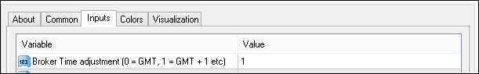

1. Go down to M1 timeframe and place crosshairs on last candle.
2. The time on the crosshair vertical line is Broker Time.
3. Offset Broker Time against GMT. Google for current GMT time.

*Attached Image (click to enlarge)*

[Click to Enlarge

Name: CT-3.PNG
Size: 22 KB](http://www.forexfactory.com/attachment.php?attachmentid=1538593&d=1414625138)

**H4 Candles Considerations**  
  
The hour durations for H4 candles are;  
0 - 4, 4 - 8, 8 -12, 12 - 16, 16 - 20, 20 - 0.  
  
In Example One

1. During BST Broker-A 8 - 12 candle started at 7 and ended at 11 BST.
2. During BWT Broker-A 8 -12 candle started at 7 and ended at 11 BWT.

In Example Two

1. During BST Broker-B 8 - 12 candle stated at 6 and ended at 10 BST.
2. During BWT Broker-B 8 - 12 candle started at 5 and ended at 9 BWT.

These considerations should be taken into account with regards to remaining countdown time on candles greater than H1.  
  
**Time Synchronization**→ Date and Time on Task Bar → Change date and time settings →Internet Time →Change settings →✔ Synchronize with an internet time server →Update now → OK  
  
**Alert Options**

1. Off
2. On
3. Sound only

*Attached Image*

http://www.forexfactory.com/attachment.php?attachmentid=1538594&stc=1&d=1414625176

New Bar Alert Status Label: can be shown or hidden.  
  
**Replace MT4 jarring Alert Sound**  
  
The MT4 default alert sound is a jarring irritation. To replace the MT4 default alert sound with something more conducive to trading, proceed as follows:

1. Go to (C: → Program Files(x86) → your MT4 → Sounds → alert.wav
2. Rename alert.wav to alertx.wav
3. Download attached zip file and copy alert.wav to the same folder as the newly renamed alertx.wav
4. Click the new alert.wav sound bite to play in media player. The new alert sound should be heard at the next alert.
5. To return the default alert delete alert.wav and rename alertx.wav to alert.wav

* The MT4 disconnect.wav sound bite is very short. For added safety the MT4 disconnect sound bite can be renamed and replaced with a sound bite of longer duration.

Free sounds can be got here - <https://www.freesound.org/> . Search bells, gongs, chimes etc.  
  
**Note 4:** Sound bites must have .wav extension to work in MT4.  
  
**Display Window**

* The countdown timer can be displayed on the main chart or a separate window such as MACD or Stocastics. Set display Window option accordingly.
* If the countdown timer is required to be displayed in its own separate window download attached zip file. Extract blank.mq4, install * and attach to chart. Set Display Window option accordingly.
* **Note 4:**When displaying in a separate window ensure that Left-Right and Up-Down are in limits otherwise the countdown timer will not be visible in the separate window. A safe setting to begin with would be 20 / 20 respectively.

*eg. C:\Users\T\AppData\Roaming\MetaQuot es\Terminal\9F61A4A5D91941F00E5E134 F12B716EB\MQL4\Indicators  
  
**Other indicators that may be of interest – here.**<https://login.mql5.com/en/users/file45/publications>  
  
**Modifications**

* Feel free to modify and post for benefit of users.
* To avoid confusion between different versions please do not name a modification the same as any existing version.

------------------------------------ ------------------------------------ ------------------------------------ ------------------------------------ -------------  
xzl Countdown Timer fix b2.mq4 - includes new bar/candle alert option.  
xzl Countdown Timer fix a2.mq4 - does not include new bar/candle alert option